Chapter 17, Solution 77.

- For the first two AC terms, the frequency ratio is 6/4 = 1.5 so that the highest common factor is 2. Hence ω_{o} = 2.

T = 2π/ω_{o} = 2π/2 = π

- The average value is the DC component = –2

- V_{rms} = 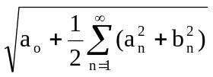

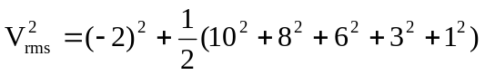 = 121.5

V_{rms} = 11.02 V

